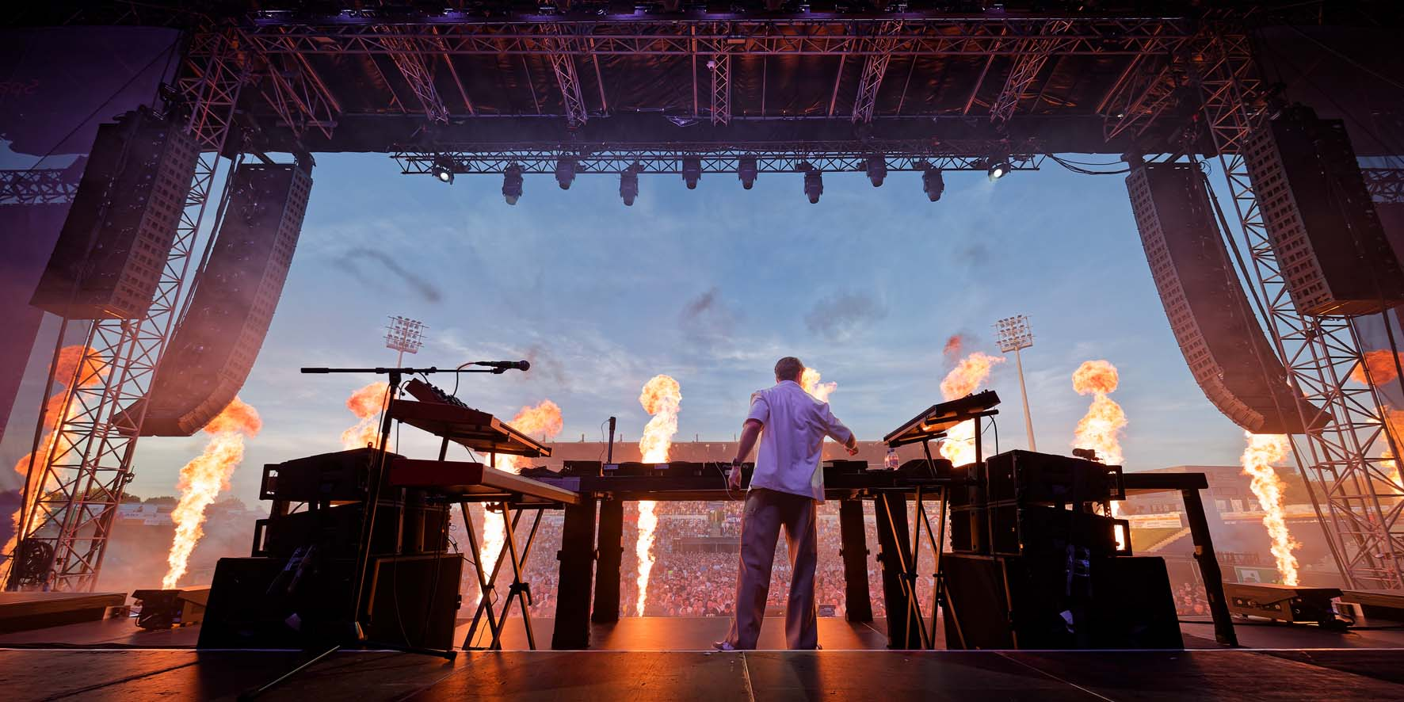

Kygo on a world tour: in-ear monitoring re-defined with Sennheiser Spectera

Wedemark, September 2026 – Following on from shows in North and South America, the Norwegian music producer, keyboard player, DJ and songwriter Kygo is making a stop in Europe before heading back to the US in September. On 8 August, he performed his spectacular open-air show at the SparkassenPark Mönchengladbach. At Europe’s biggest hockey arena, Kygo’s fans were treated to a Tropical House night featuring his greatest hits and showcasing a host of special guests. Wireless in-ear monitoring for all performers and the crew was provided by Sennheiser Spectera.

Kygo, his crew, the guest vocalists, six string musicians and a marching percussion band all used Spectera for in-ear monitoring | 

System architecture with MADI connection
The centrepiece of the wireless monitoring was a Sennheiser Spectera Base Station installed in a 19” rack right next to the monitoring console. The rack also accommodated three modular L 6000 charging stations for the BA 70 lithium-ion battery packs for the 24 Spectera SEK bodypacks in use. The bidirectional bodypacks were configured as receivers for 14 stereo in-ear mixes. Three of the four Spectera DAD antennas taken to the venue were used and set up on stands. The Spectera WebUI software ensured a clear overview of the system and provided comprehensive remote control options.

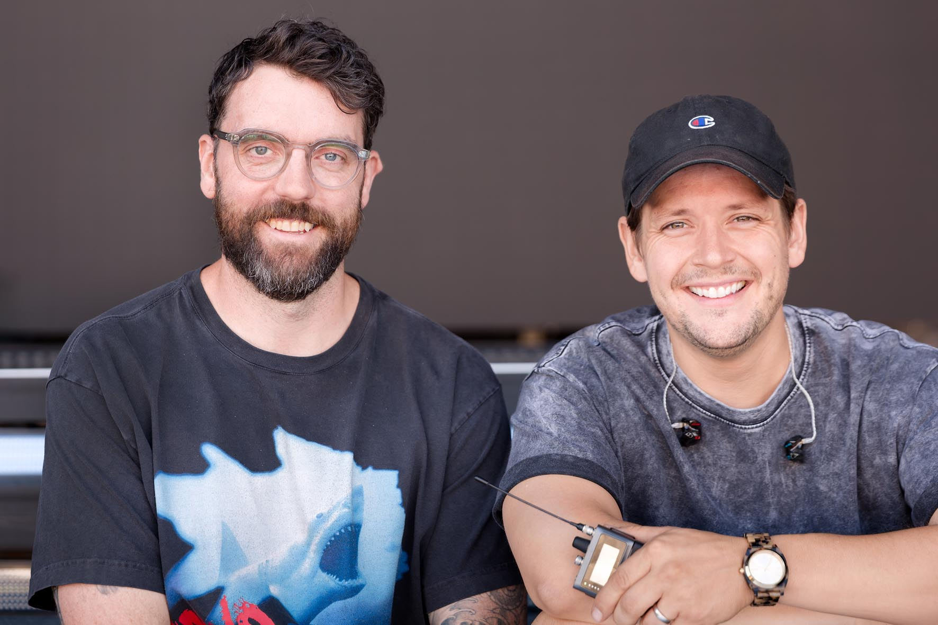 | Ross James Mulhare (left, FOH) and Kevin Flasza (Monitors)

The Spectera Base Station was operated in the UHF band, with centre frequencies of 546 MHz and 578 MHz for the 8 MHz blocks. Power was supplied via a redundant system from the power grid and a UPS. The main connections were available through an interface panel at the back of the 19” rack. The audio signals were sent to the monitoring console via MADI using coaxial BNC point-to-point cabling. The sampling rate was 96 kHz, the Audio Link Mode was set at “Live Low Latency” with a latency of 1.1 ms (Extended Range, SeDAC).

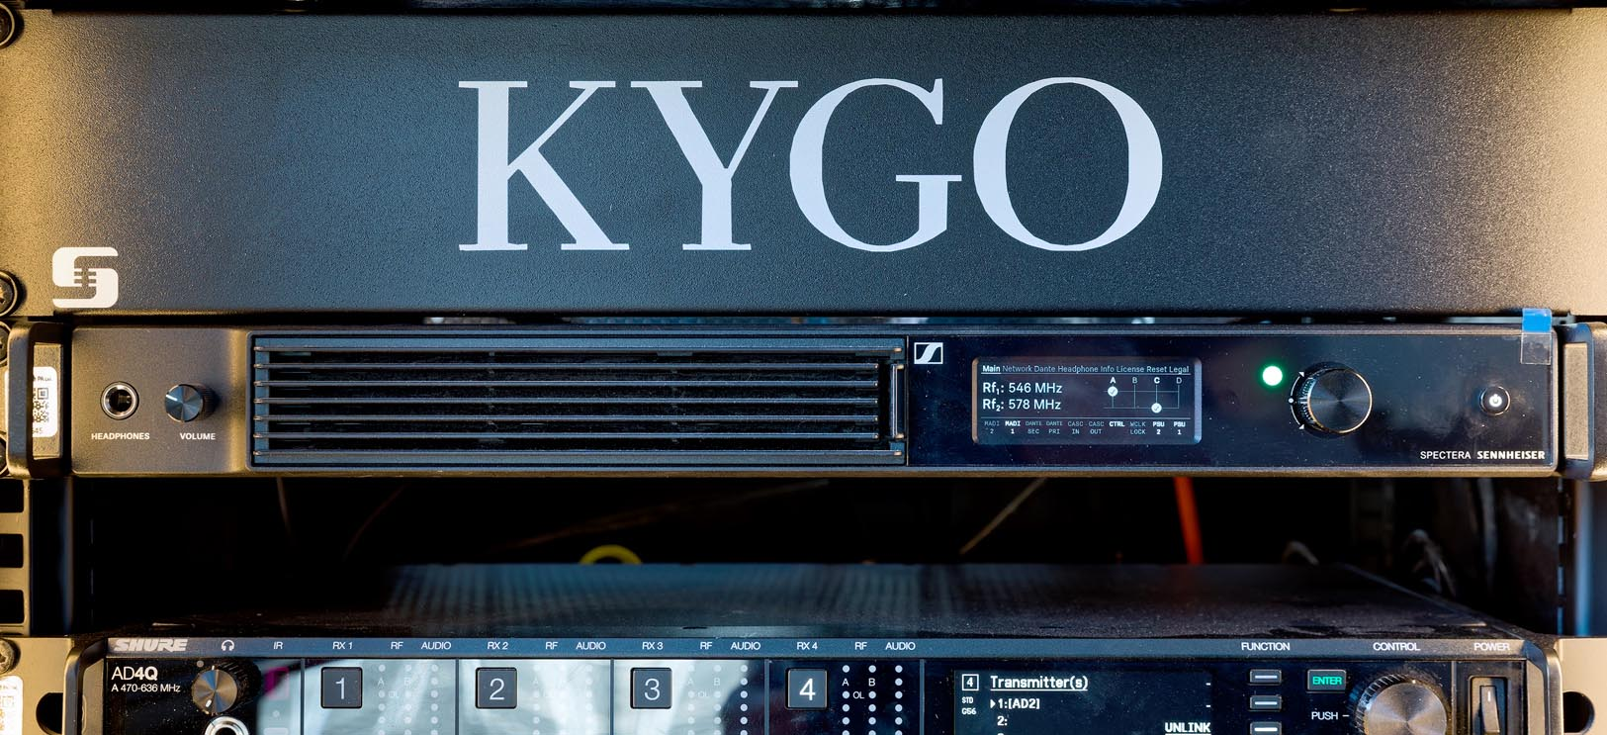 | The Spectera Base Station at the monitoring console was operated with two RF wideband channels with centre frequencies of 546 and 578 MHz

Perfect for global logistics: Spectera on tour
The Sennheiser equipment was supplied by the UK-based companies Studio 89 and Pulse PA Limited (www.pulsepa.co.uk). Ross James Mulhare (Instagram: @the_rossjames), founder and owner of Studio 89, was responsible for setting up the Spectera system in Mönchengladbach and also for the FOH mix during the show.

“Two of the many features that make the new Sennheiser Spectera system so impressive are its compact packing size and its low weight,” says Mulhare, who has had a successful career in the professional audio industry for many years and also has a background as a musician. He can often be found at the FOH and monitoring consoles during touring productions. His references include working with big names such as The Sugarbabes, Gary Barlow and Ronan Keating. He has now been working for Kygo for four years.

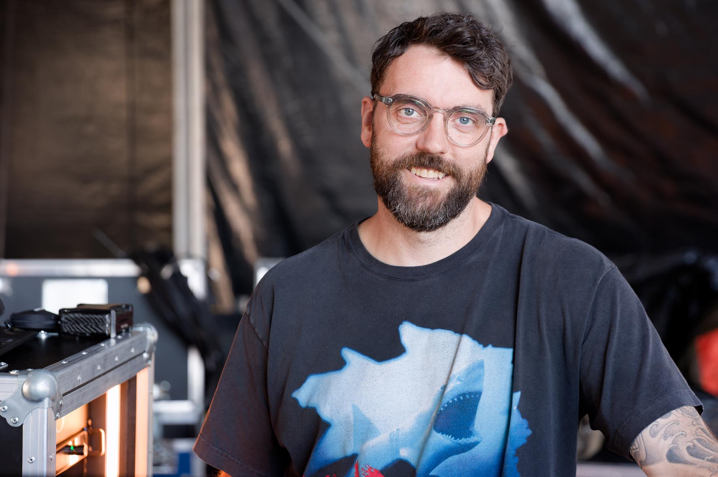 | Ross James Mulhare, founder and owner of Studio 89, was responsible for setting up the Spectera system and for the FOH mix

“Kygo’s tour takes him all over the world, and besides Europe we often perform in North and South America as well as in Asia,” says Mulhare. “We used to work a lot with locally hired equipment, which can often be a real challenge. But in the meantime, we’ve put together a touring package that’s perfect for our needs, and Spectera is now a key component of this. For worldwide tours, we have an A set and a B set, and because both have to be dispatched by air freight, they need to be as compact and light as possible.”

One of the three Spectera DAD antennas deployed in the stadium | 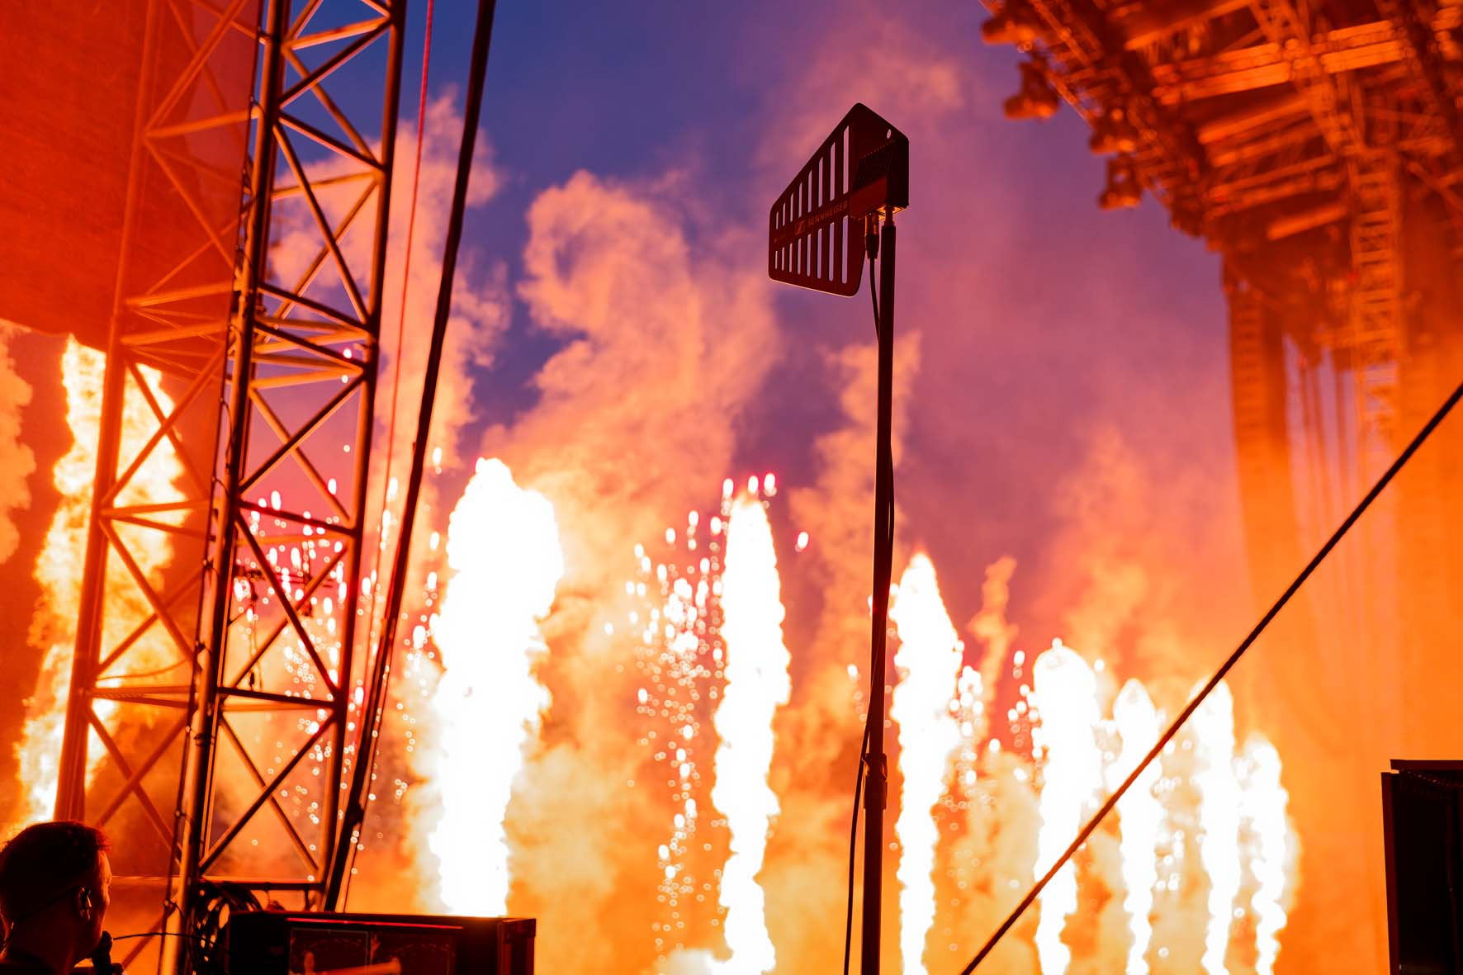

Mulhare adds: “One feature that is extremely useful for me is the fact that the Spectera DAD antennas are connected to the Base Station via conventional network cables. That speeds up and simplifies the workflow when setting up. And if necessary, you can always get replacement cables quickly wherever you are on tour. In Mönchengladbach, we use three DAD antennas: two for the stage and one for the backstage area, where Kygo is accompanied live by a video camera on his way to the stage. We use the fourth antenna whenever the stage design includes a long catwalk.”

Workflow into a wideband future
In the past, Mulhare often used wireless systems from another company for touring. His first contact with the Sennheiser Spectera ecosystem was through Angus Price, the managing director of Pulse PA Limited. “It was Angus who introduced me to Spectera and he gave me the opportunity to put the system through its paces at his company’s premises,” he recalls. “I quickly became aware of the many possibilities that it offers, especially because Angus was there to help me with all his experience. In January 2026, I was at a trade fair in the UK where I was able to take part in a Spectera demo. Having used products from a different manufacturer for many years, I couldn’t really imagine changing to a new system at first – but as you can now see from the Kygo shows, that mindset wasn’t set in stone…,” he said with a smile.

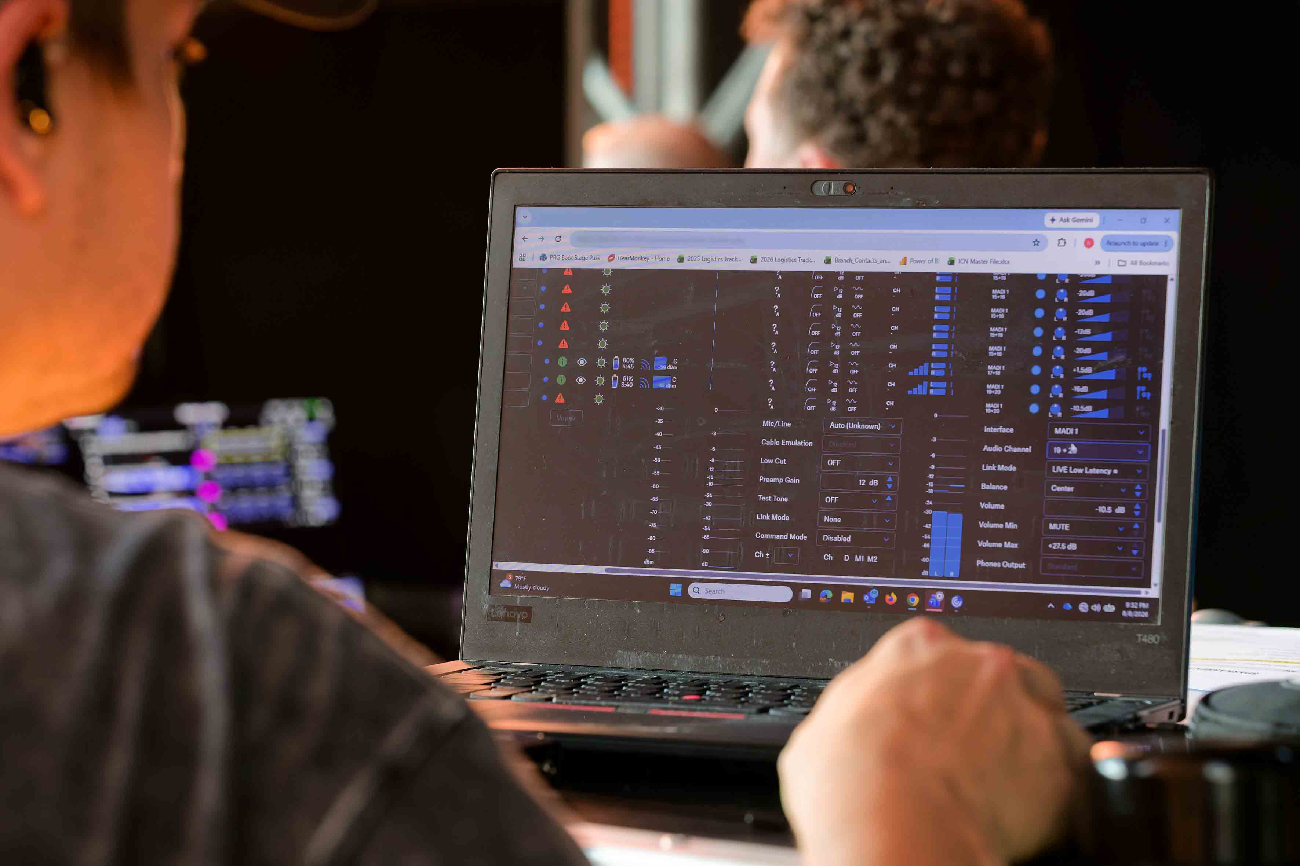 | Spectera WebUI is intuitive to operate

Mulhare stresses that configuring a ready-to-play setup at a new location can be carried out much more quickly with Spectera than with conventional wireless systems. “At the moment, we use the Spectera WebUI software, which is intuitive to operate,” he says. “I haven’t yet had the chance to try out the SoundBase Pro software, but I find its concept very interesting.”

Mulhare rejects the well-worn cliché that DJs simply turn up at EDM shows with a USB stick, and therefore not much work is required at the mixing console: “Kygo plays various synthesizers during his show and often performs at a real grand piano – he’s a really excellent keyboard player! In addition, he invites various singers onto the stage as guest vocalists for some of songs, and today in Mönchengladbach, he will also be accompanied by an ensemble of six string musicians and a marching percussion band. It’s by no means a trivial task to get the FOH mix and in-ear monitoring just right.”

Sound with a “wow” effect: Spectera for IEM
The monitoring console in Mönchengladbach was operated by Kevin Flasza (Instagram: @enjoyakevinsicle). The US sound engineer lives in Berwyn, Illinois (Chicago metropolitan area), is a full-time employee of the Production Resource Group (PRG) and has wide-ranging expertise in the field of live audio. He graduated with a Bachelor of Arts in Audio Arts from Columbia College Chicago. Flasza has been accompanying Kygo on tour in various sound engineering roles since 2018, and used the Sennheiser Spectera ecosystem for the first time at the performance in Mönchengladbach.

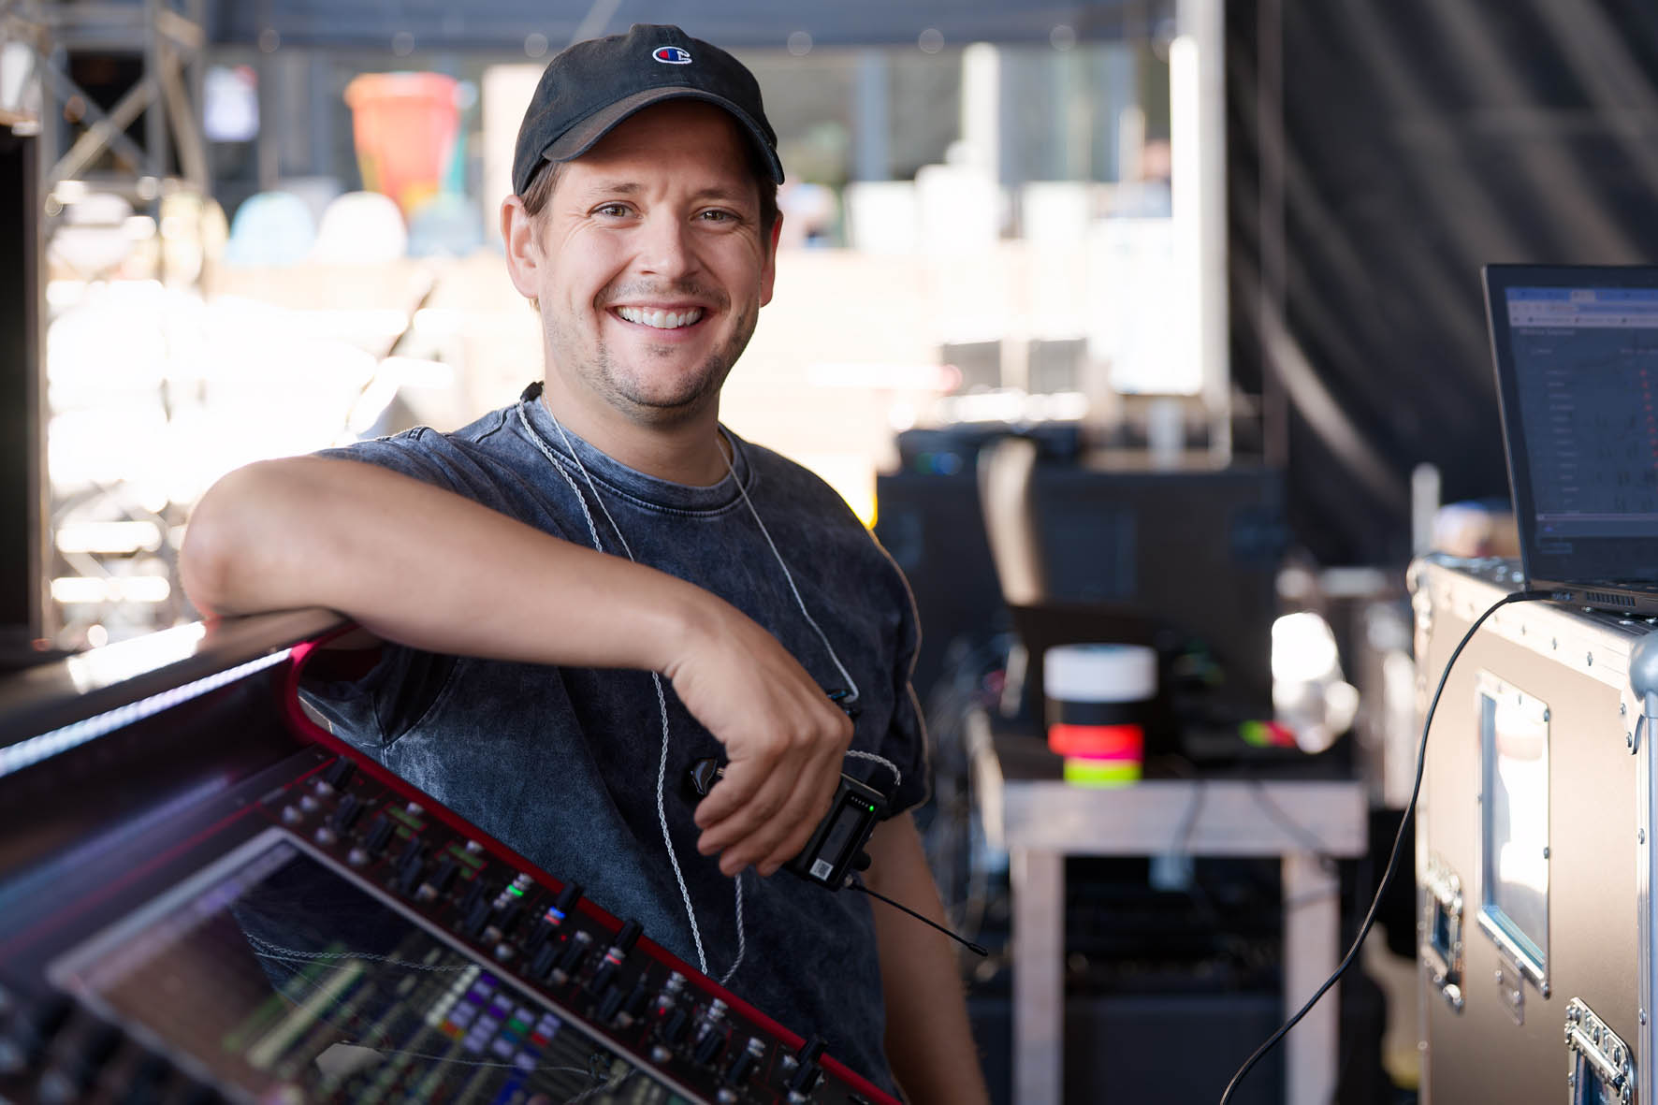 | Kevin Flasza was responsible for the monitor sound

“To be honest, I was a bit nervous beforehand about working on such a big show and having to rely on a wireless system that was completely new to me,” Flasza admits. “But after the set-up and the sound check, I realized that there was no reason for me to be nervous at all, especially since I’ve worked with Sennheiser wireless equipment many times in the past. I know that people used to talk a lot about latency in digital in-ear systems. Personally, however, I’ve always argued that that this isn’t as important in live performances as it is, for example, in studio recordings.”

Conventional monitor speakers were not used for Kygo’s show. Only at the actual DJ console itself were side stacks set up on the left and right, each consisting of two top speakers and one subwoofer.

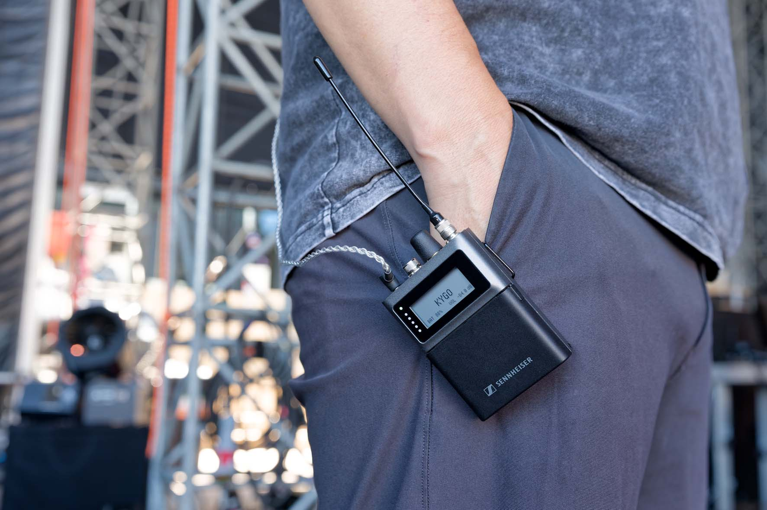 | Kevin Flasza: “When I connected to the Spectera system for the first time using the SEK bodypack, it had quite a “wow” effect.”

Flasza continues: “When I connected to the Spectera system for the first time using the SEK bodypack, it had quite a “wow” effect. Yesterday, we had a show at the UNTOLD Festival in Cluj-Napoca in Romania, where a wireless system from a competitor company was being used. I must say: the difference between yesterday and today is absolutely immense, and I immediately understood why Ross, who was responsible for setting up the system, speaks so highly of Spectera. The sound transmission is exceptionally smooth, with an extremely low noise floor, and in my opinion the music sounds fuller than it does with other products. You could even say that the sound seems to have a shiny finish, as if it has been polished. It’s just so much fun!”

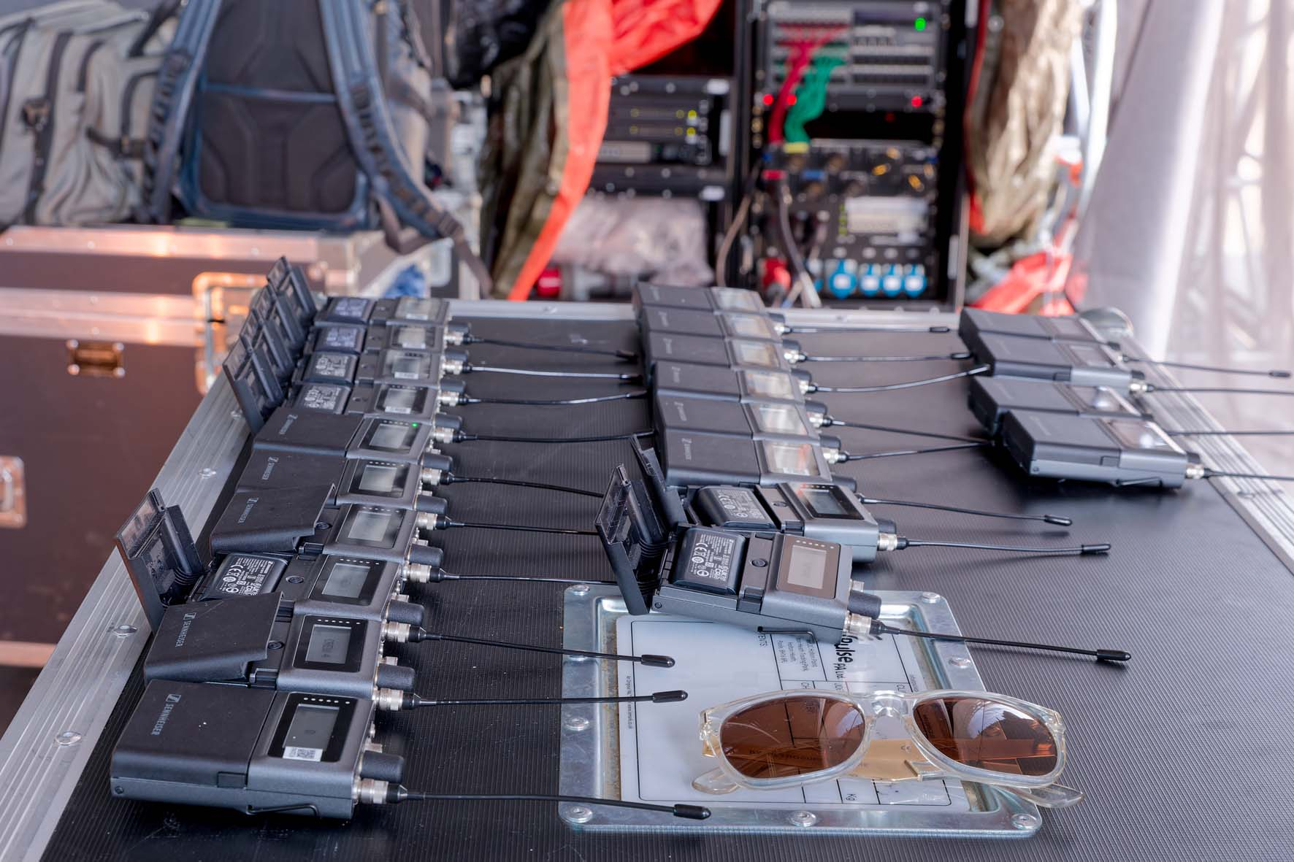 | A small footprint: a single 19” Base Station provides the 14 stereo in-ear mixes required for the show

“What I also find fascinating is that a single 19” device with just 1U is able to provide the 14 stereo in-ear mixes required for Kygo’s show,” says Flasza. “As far as the SEK bodypacks are concerned, I first had to get used to the fact that the on/off switch is located under a cover, and the endless rotary encoder is also something new for me. A really cool feature is the e-ink display, which continues to show the performer’s name when it is switched off – it definitely looks a lot better than a piece of sticky tape with my handwriting on it…” (Flasza laughs).

The wireless set-up of tomorrow
Mulhare is already looking forward to the brand-new Sennheiser Spectera SKM handheld transmitters: “I’m waiting for a demo model that’s expected to arrive at Studio 89 next week. I intend to take the handheld transmitter with me to a show by Australian indie rock band Gang of Youths, where I’ve been using Spectera for some time now. As far as Kygo is concerned, the first step will be to equip the crew with Sennheiser headsets for talkback purposes, and these will be connected to the Spectera SEK bodypacks. This will enable us to benefit directly from the bidirectional functionality. In addition, I can certainly imagine using Spectera SKM handheld transmitters with capsules such as the MMD 945 or the MM 445 for Kygo’s vocals and for his guest vocalists, as I’m really impressed by the sound they deliver. And then, in the not-too-distant future, we will probably add a second base station as well…”



About Kygo
The Norwegian music producer, keyboard player and DJ Kygo (www.kygomusic.com) has played a key role in shaping electronic pop music over the past decade. In his music, Kyrre Gørvell-Dahll – Kygo’s real name – is often active in a subgenre of electronic dance music called “Tropical House”, and he is seen as one of its co-founders. In contrast to the more aggressive sound of typical EDM productions, Tropical House focuses on slowing down the pace and creating a summery vibe. Attractive arrangements featuring synthetic pan flutes, marimbas, and acoustic guitar parts that are reminiscent of evenings by the campfire, combined with laid-back, groovy bass lines and four-on-the-floor drums, all go together to produce a wonderfully relaxed atmosphere.
Kygo first made a name for himself with bootlegs, including a remix of Ed Sheeran’s “I See Fire”, before achieving his worldwide breakthrough with the single “Firestone”. Today, the Norwegian artist, who was born in Singapore, gets billions of streams on the major platforms. In addition to “Firestone”, his greatest hits include, in particular, his collaboration “It Ain’t Me” with Selena Gomez, a re-interpretation of the Whitney Houston classic “Higher Love” and “Stole the Show”. His fifth studio album “Kygo” went to No. 2 in the US Billboard Dance Charts and became his third chart-topping album in his home country of Norway.

(Ends)

All images © Sennheiser with kind photo permission of the production team.

The images accompanying this media release, plus additional images, can be downloaded in web resolution jpgs or as high-resolution TIFF files.

About Sennheiser
We live and breathe audio. We are driven by the passion to create audio solutions that make a difference. This passion has taken us from the world’s greatest stages to the quietest listening rooms – and made Sennheiser the name behind audio that doesn’t just sound good: It feels true. Since 1945, we have stood for building the future of audio and bringing remarkable sound experiences to our customers. While professional audio solutions such as microphones, meeting solutions, streaming technologies, professional headphones, automotive audio solutions, as well as wireless microphone and monitoring systems are part of the business of Sennheiser electronic SE & Co. KG, the business with consumer devices such as headphones, soundbars and speech-enhanced hearables is operated by Sonova Holding AG under the license of Sennheiser.

www.sennheiser.com
www.sennheiser-hearing.com

Press Contacts UK
Stephanie Schmidt Sarah James
stephanie.schmidt@sennheiser.com sarahj@gasolinemedia.com
+49 5130 6001275 +44 (0)7702 421635

